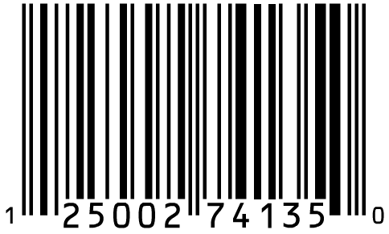

© Kids’ Club. All rights reserved.
All scripture referenced herein is from the New International Version (NIV) of the Bible.

Church Name
Here

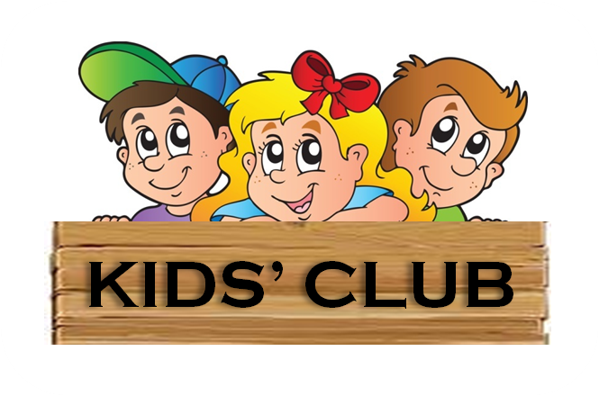

Name ________________________ Grade ___
Hey Kids,
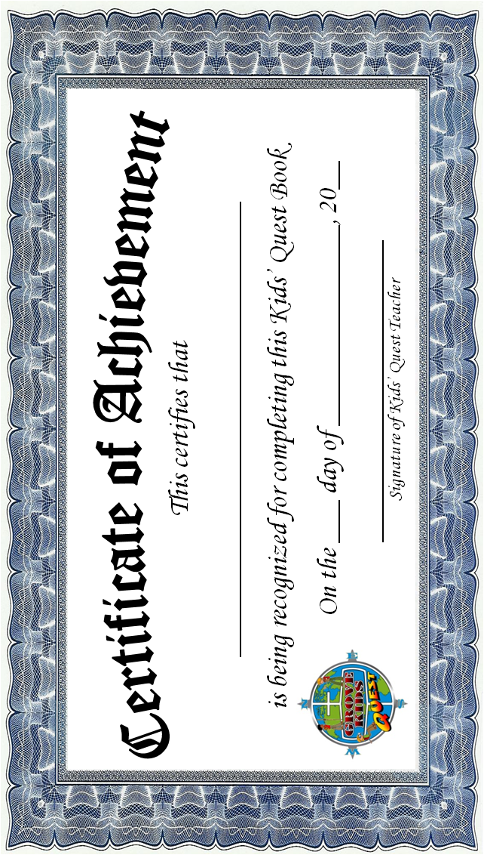
The Grove Kids’ Quest is pleased to provide you with the opportunity to earn a Kids’ Quest Medal of Achievement! By answering questions and memorizing bible verses from the stories you will be learning in Grove Kids’ Quest, you can earn the fabulous medal seen below.
To earn your medal, you must read the bible stories (or have a parent/guardian read them to you) and answer the questions aloud to your parent/guardian. They will award you points based on how well you answer the questions. A total score for the questions of 16 out 20 points is satisfactory.
Next, memorize the memory verse for the week and recite it aloud to your parent/guardian. Your parent/guardian may help you with up to two words. A passing score for the memory verse is 8 out of 10 points.
Have your parent/guardian total up the points, sign, and date each section that you complete. When all of the sections in this book have been have been signed off, have your parent/guardian fill out the Completion Notice at the end of this book and then return the book to your Kids’ Quest teacher. Your Kids’ Quest teacher will fill out the award on the back cover and then submit your Completion Notice to the Kids’ Quest Coordinator. You may keep your completed book.
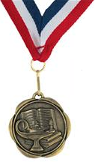
Once you have completed all four (4) books, and the Kids’ Quest Coordinator receives four (4) Completion notices, you will be awarded your Kids’ Quest Medal of Achievement!

